Algebra 2B Unit Test Guide

Modeling Data Distributions Unit Test

Item | Lesson Coverage | Objective | Mathematical Practice Standard | Lesson Page | Assessment Item
1 | Lesson 2: Shape, Center, and Spread | In this lesson, you will distinguish between symmetric and skewed distributions. | Make sense of problems and persevere in solving them. | p. 1-7 | Use the image to answer the question.  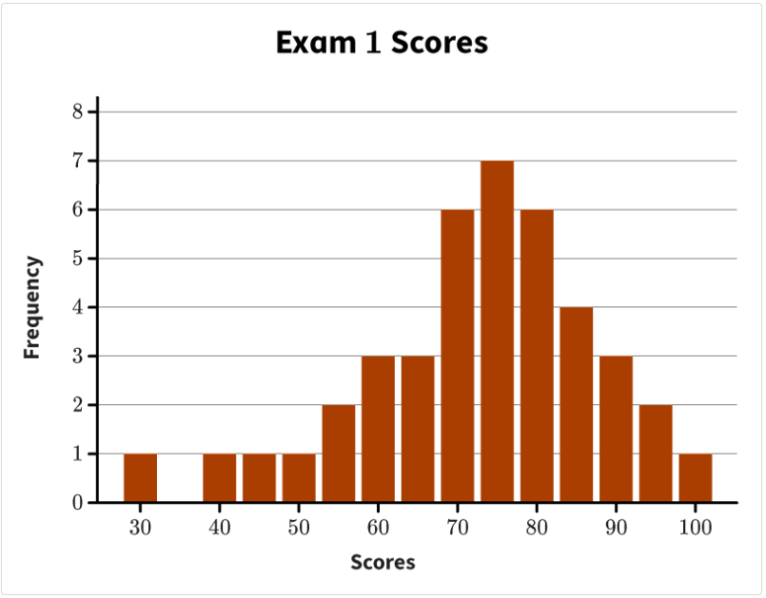  Given is the histogram of Exam 1 scores from Ms. Mala’s Algebra 1 class. Which option correctly describes the shape of Ms. Mala’s Exam 1 scores?  Correct answer: skewed left
2 | Lesson 2: Shape, Center, and Spread | In this lesson, you will distinguish between symmetric and skewed distributions. | Make sense of problems and persevere in solving them. | p. 1-7 | Given that men’s height data are symmetric, which graph can possibly be a representation of men's height?  Correct answer:  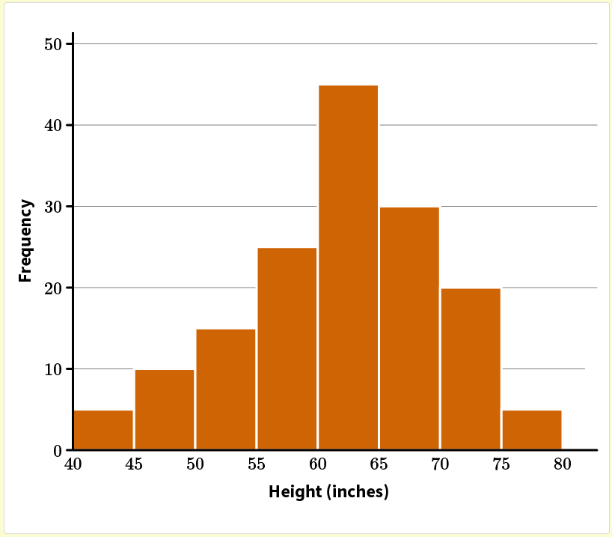
3 | Lesson 2: Shape, Center, and Spread | In this section, you will interpret the mean as a typical value of a distribution and the standard deviation as a typical distance a value is from the mean. | Make sense of problems and persevere in solving them. | p. 8-15 | A data set has mean $μ$ and standard deviation $σ$. Which statement is correct?  Correct answer: A value chosen randomly from the data set will typically be contained in the interval $\left[μ-σ, μ+σ\right]$.
4 | Lesson 2: Shape, Center, and Spread | In this section, you will interpret the mean as a typical value of a distribution and the standard deviation as a typical distance a value is from the mean. | Make sense of problems and persevere in solving them. | p. 8-15 | Find the mean and standard deviation for the following data set. Round to the nearest tenth. 11, 14, 15, 15, 16, 16, 17, 18, 19, 23. Use the mean and standard deviation to select the correct statement.  Correct answer: 16.4 is a typical value for the data set. 3.0 is the typical distance that a value in the data set is from 16.4.  Modeling Data Distributions Unit Test Item #4 - GeoGebra
5 | Lesson 2: Shape, Center, and Spread | In this section, you will discuss estimates of the mean and standard deviation, and their reasonableness, for symmetric and skewed distributions. | Use appropriate tools strategically. | p. 16-22 | Use the image to answer the question.  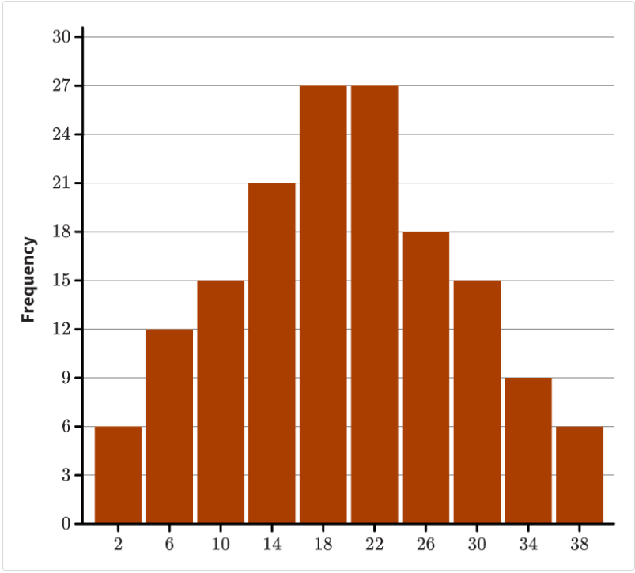  Which number is the best estimate of the standard deviation for the distribution shown?  Correct answer: 8  Modeling Data Distributions Unit Test Item #5 - GeoGebra
6 | Lesson 4: The Normal Curve | In this section, you will use a smooth curve to model a data distribution. | Reason abstractly and quantitatively. | p. 1-7 | Use the image to answer the question.  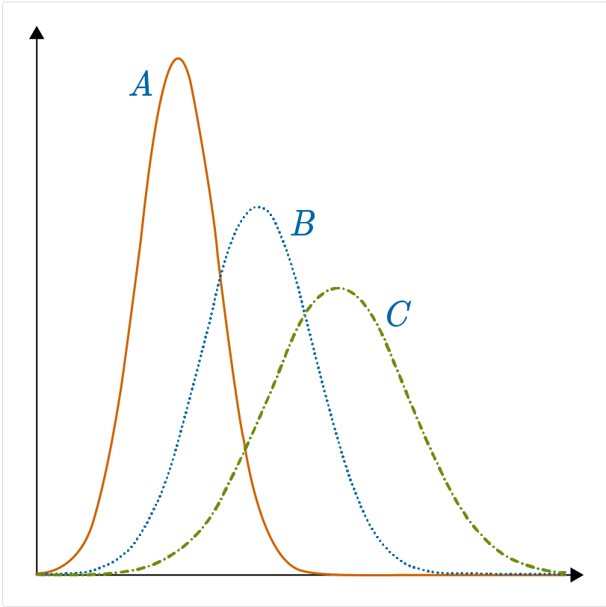  Which statement about the curves is true?  Correct answer: Curve A has the lowest mode.
7 | Lesson 4: The Normal Curve | In this section, you will use a smooth curve to model a data distribution. | Reason abstractly and quantitatively. | p. 1-7 | Use the image to answer the question.  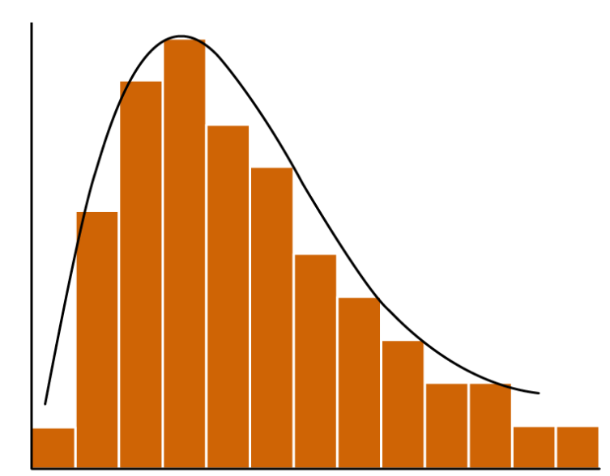  Isabelle creates the smooth curve to model the data in the histogram. What does she know about the shape of the curve?  Correct answer: The curve is skewed.
8 | Lesson 4: The Normal Curve | In this section, you will learn about the attributes of a normal curve and how to use them to describe different probability distributions. | Construct viable arguments and critique the reasoning of others. | p. 8-13 | The mean score on a particular test is 79 and the standard deviation is 5.5. What is the probability that a randomly selected test score is more than 90?  Correct answer: 5%  Modeling Data Distributions Unit Test Item #8 - GeoGebra
9 | Lesson 4: The Normal Curve | In this section, you will learn about the attributes of a normal curve and how to use them to describe different probability distributions. | Construct viable arguments and critique the reasoning of others. | p. 8-13 | The male shoe sizes within a community are normally distributed with a mean of $μ=10$ and a standard deviation of $σ=1.5$ . Apply the Empirical Rule to find the probability that a man will have a shoe size between 13 and 14.5.  Correct answer: 2.35%  Modeling Data Distributions Unit Test Item #9 - GeoGebra
10 | Lesson 4: The Normal Curve | In this section, you will recognize when it is reasonable to use a normal curve as a model for a distribution. | Look for and express regularity in repeated reasoning. | p. 14-20 | A normal distribution has a mean of 645.33 and a standard deviation of 12.78. Approximately 68 percent of the data will lie between which two values?  Correct answer: 632.55 to 658.11  Modeling Data Distributions Unit Test Item #10 - GeoGebra
11 | Lesson 5: Area Under a Normal Curve | In this section, you will calculate z-scores. | Use appropriate tools strategically. | p. 1-5 | In a certain neighborhood, the average number of candies received while trick-or-treating is 50, with a standard deviation of 12. If Isaac received 40 candies, calculate his z-score to the nearest thousandth.  Correct answer: z = -0.833  Modeling Data Distributions Unit Test Item #11 - GeoGebra
12 | Lesson 5: Area Under a Normal Curve | In this section, you will calculate z-scores. | Use appropriate tools strategically. | p. 1-5 | Given a population mean of 135 and a standard deviation of 5, what data point, x, would result in a z-score of 1.6?  Correct answer: x = 143  Modeling Data Distributions Unit Test Item #12 - GeoGebra
13 | Lesson 5: Area Under a Normal Curve | In this section, you will use z-scores to estimate the area under a normal curve. | Use appropriate tools strategically. | p. 6-13 | Estimate the area percentage under a normal curve between a z-score of 0.21 and 1.67.  Correct answer: 36.93 percent  z-score calculator – GeoGebra: This applet shows the probability of a z score below, above and between two values as a decimal.  Modeling Data Distributions Unit Test Item #13 - GeoGebra
14 | Lesson 5: Area Under a Normal Curve | In this section, you will use z-scores to estimate the area under a normal curve. | Use appropriate tools strategically. | p. 6-13 | Estimate the area percentage under a normal curve to the right of a z-score of 0.35.  Correct answer: 36.32 percent  Modeling Data Distributions Unit Test Item #14 - GeoGebra
15 | Lesson 5: Area Under a Normal Curve | In this section, you will use the area under normal curves to calculate probabilities of events. | Reason abstractly and quantitatively. | p. 14-19 | Use the table to answer the question.  [SEE TABLE ONLINE]  The mean height of a group of plants is 20 centimeters, with a standard deviation of 3 centimeters. What is the probability that a randomly selected plant is between 20.2 cm and 24.9 cm tall? Give the answer as a percentage to the hundredths place.  The probability that a randomly selected plant is between 20.2 and 24.9 centimeters tall is _%.  Correct answer: 42.05  z-score calculator – GeoGebra: This applet shows the probability of a z score below, above and between two values as a decimal.  Modeling Data Distributions Unit Test Item #15 - GeoGebra
16 | Lesson 6: Modeling with Normal Distributions | In this section, you will use technology to estimate the area under a normal curve. | Use appropriate tools strategically. | p. 1-6 | A kayak-rental company needs to replace many of its kayaks, and it wants to ensure it has enough kayaks to meet the demand from customers during the summer season. On average, it rents out 42 kayaks each day with a standard deviation of 4. The company has 45 kayaks. Use a calculator or spreadsheet program to find the probability that the company will have enough kayaks on any given day. Round the answer to the nearest tenth.  The probability that there are enough kayaks on any given day is _.  Correct answer: 77.3  Modeling Data Distributions Unit Test Item #16 - GeoGebra
17 | Lesson 6: Modeling with Normal Distributions | In this section, you will use technology to estimate the area under a normal curve. | Use appropriate tools strategically. | p. 1-6 | The number of books that high school students in the United States read in a year is normally distributed with a mean of 25 books and a standard deviation of 2.5 books. Complete the input for the spreadsheet program to calculate the probability that a high school student chosen at random will read more than 28 books in a year. Then identify this probability. Round the answers to the nearest tenth.  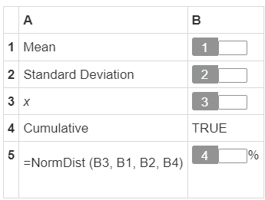  Correct answers:  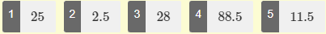  Modeling Data Distributions Unit Test Item #17 (blank 4) - GeoGebra  Modeling Data Distributions Unit Test Item #17 (blank 5) - GeoGebra  *blank #4 and #5 can be found by toggling between left-sided and right-sided intervals.
18 | Lesson 6: Modeling with Normal Distributions | In this section, you will model data distributions with appropriate normal distributions. | Make sense of problems and persevere in solving them. | p. 7-12 | What is the mean of the dataset in the normal model N (352, 12)?  mean = _  Correct answer: 352  Modeling Data Distributions Unit Test Item #18a - GeoGebra  Modeling Data Distributions Unit Test Item #18b - GeoGebra
19 | Lesson 6: Modeling with Normal Distributions | In this section, you will model data distributions with appropriate normal distributions. | Make sense of problems and persevere in solving them. | p. 7-12 | Mona is given the model N (1400, 200) for a set of 50 data and wants to make some predictions. About how many data points should she expect to find between 1000 and 1800?  Correct answer: 47  Modeling Data Distributions Unit Test Item #19a - GeoGebra  Modeling Data Distributions Unit Test Item #19b - GeoGebra
20 | Lesson 2: Shape, Center, and Spread | In this section, you will discuss estimates of the mean and standard deviation, and their reasonableness, for symmetric and skewed distributions. | Use appropriate tools strategically. | p. 16-22 | Use the image to answer the question.  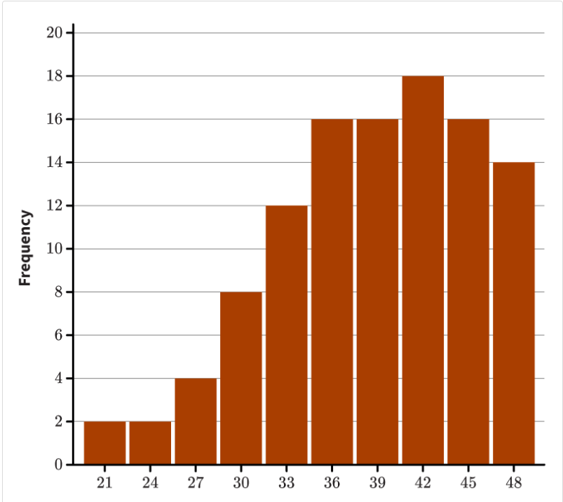  Estimate the mean for the distribution shown. State the estimated mean and explain why your answer is reasonable.  Correct answer: The exact mean for this distribution is 38.7. Student answers should be close to this number but be less than 42. Students should point out that the distribution is skewed left, so the mean is to the left of the median which is to the left of the mode. Since the mode is 42, the estimated mean is slightly less than 42.  Modeling Data Distributions Unit Test Item #20 - GeoGebra
21 | Lesson 4: The Normal Curve | In this section, you will recognize when it is reasonable to use a normal curve as a model for a distribution. | Look for and express regularity in repeated reasoning. | p. 14-20 | In 1–2 sentences, describe the three characteristics of a normal distribution.  Correct answer: Student answers should explain that the first characteristic of a normal distribution is an approximately symmetrical bell-shape. The second characteristic is an approximately equal mean and median that lie near the center of the distribution. Lastly, the values will follow the Empirical Rule.
22 | Lesson 5: Area Under a Normal Curve | In this section, you will use the area under normal curves to calculate probabilities of events. | Reason abstractly and quantitatively. | p. 14-19 | Use the table to answer the question.  [SEE TABLE ONLINE]  The mean weight of a herd of white-tailed deer is 140.3 pounds, with a standard deviation of 7.2 pounds. What is the probability that a randomly selected deer weighs more than 149 pounds?  Correct answer: Since the weight of a herd of white-tailed deer is normally distributed, students should start by drawing a normal curve with the mean labeled at 140.3 lbs. and a mark at approximately 149 lbs. They should use the z-score formula to determine a z-score of 1.21.  $$z=\frac{149-140.3}{7.2}=1.21$$  They should use the given chart to determine the probability associated with $z=1.21$, which is 0.8869. But they should realize that this probability represents the area below $z=1.21$, while they want to find the area above.  $$P\left(x≥149\right)=1-0.8869=0.1131$$  Therefore, the probability that a randomly chosen deer will weigh more than 149 pounds is 0.1131 or 11.31%.  That is, $P\left(x≥149\right)=0.1131$.  Modeling Data Distributions Unit Test Item #22 - GeoGebra

