Algebra 2B

Unit 4: Finite Geometric Series
Unit Summary:
In this unit, you will learn how to find the sum of an infinite number of terms in a geometric series. You will also learn a shortcut for writing sums of geometric series instead of having to write out a long string of summed terms. These notations and formulas will be used to help you calculate amounts of money saved over time and calculate payment plans to determine the value of a recurring payment.
Lesson 2 – From Sequence Come Series
Key Words:
- arithmetic sequence – a sequence (such as 1, 3, 5) in which the difference between a term and its predecessor is always the same
- common difference – the difference between two consecutive terms of an arithmetic progression
- common ratio – the ratio of each term of a geometric progression to its preceding term
- finite sequence – a finite succession of terms or of factors proceeding according to some mathematical law
- geometric sequence – a sequence (such as 1, $\frac{1}{2}, \frac{1}{4}…$) in which the ratio of a term to its predecessor is always the same
- geometric series – a series (such as $1+x+x^{2}+x^{3}+…$) whose terms form a geometric progression
- infinite sequence – an endless succession of terms or of factors proceeding according to some mathematical law
- sequence – a set of numbers that follow a specific pattern or formula
- series – a series is formed by adding the terms of a sequence
- sigma notation – a method used to write out a long summation in a concise way

Objective 1: In this section, you will create a geometric series in summation notation from a geometric sequence.
Mathematical Practice Standard: Model with mathematics.
Big Ideas:
- Arithmetic sequences use addition or subtraction to determine the pattern of its terms.
  - Ex: 3, 6, 9, 12, 15, 18, 21
    - This sequence contains a common difference of 3. That is, each term in the sequence increases by 3 from the previous term in the sequence.
  - In an arithmetic sequence, the common difference can be found by subtracting any term in the sequence by the previous term.
- A geometric sequence uses multiplication or division to determine the pattern of its terms.
  - Ex: 2, 8, 32, 128, 512, 2, 048, 8, 192
    - This sequence contains a common ratio of 4. That is, each term in the sequence is multiplied by 4 to get the succeeding term.
  - For a sequence to be geometric, every number in the sequence (except the first) must return the same value when divided by the previous value
- Adding the terms of a geometric sequence creates a geometric series. We use sigma notation to write a geometric series in a shorter format than listing all the terms.
  - $\sum_{n=1}^{n}{{ar}^{n-1}}$
    - $a$ represents the first term in the series
    - $n$ represents the number of terms in the series
    - $r$ represents the common ration of the series
  - The purpose of sigma notation is to evaluate ${ar}^{n-1}$ $n$ times and find the sum of the results.
  - Ex: geometric sequence: 0.25, 0.5, 1, 2, 4, 8, 16
    - The first term, $a=0.25$
    - The number of terms in the series, $n=7$
    - The common ration, $r=2$
      - The common ration was calculated using the ratio of 8 and 4. (However, any ratio used in this geometric sequence will provide the value of 2.)
    - $\sum_{n=1}^{7}{{\left(0.25\right)2}^{n-1}}$
Objective 2: In this section, you will create a geometric series from a verbal description.
Mathematical Practice Standard: Model with mathematics.
Big Ideas:
- Creating a table to gather the values needed from a verbal description may be helpful.
Values to Identify | Values
$a$ (first term)
$r$ (common ratio)
$n$ (number of terms)
  - Then plug the values into the sigma notation $\sum_{n=1}^{n}{{ar}^{n-1}}$
Objective 3: In this section, you will manually sum the first terms of a geometric sequence.
Mathematical Practice Standard: Model with mathematics.
Big Ideas:
- In order to manually sum the first terms, you must use the ${ar}^{n-1}$ expression to calculate each term by using values for $n$, from 1 to $n$, and adding them together.
  - Ex: $\sum_{n=1}^{4}{{(3)(2)}^{n-1}}$
    - $n=4$, so you need to calculate ${(3)(2)}^{n-1}$ substituting in values for $n$, from 1 through 4
$${(3)(2)}^{1-1}+{(3)(2)}^{2-1}+{(3)(2)}^{3-1}+{(3)(2)}^{4-1}$$ | Write out the equation to calculate
$${(3)(2)}^{0}+{(3)(2)}^{1}+{(3)(2)}^{2}+{(3)(2)}^{3}$$ | Simplify
$$(3)(1)+(3)(2)+(3)(4)+(3)(8)$$ | Calculate
$$3+6+12+24=45$$ | Answer

Practice Questions and Answers
 | Question | Answer
P 1 | 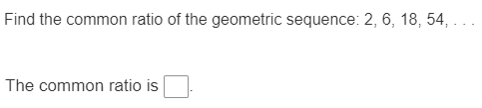 | 3
P 2 | 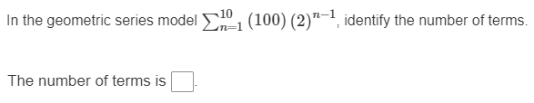 | 10
P 3 | 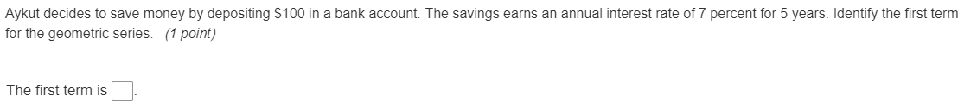 | 100
P 4 | 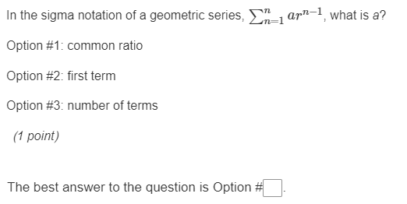 | Option 1
P 5 | 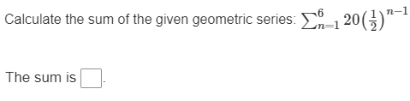 | 39.375

Quick Check Questions and Answers
 | Question | Answer
Q 1 | 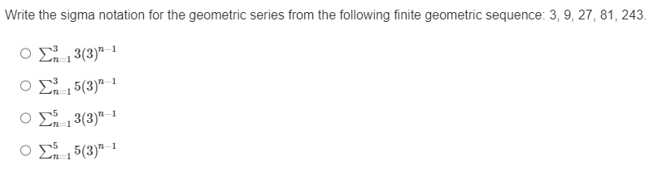 | $$\sum_{n=1}^{5}{{3(3)}^{n-1}}$$
Q 2 | 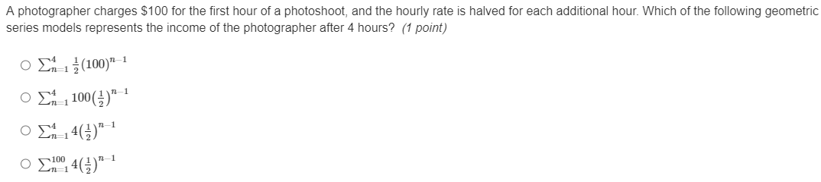 | $$\sum_{n=1}^{4}{{100(\frac{1}{2})}^{n-1}}$$
Q 3 | 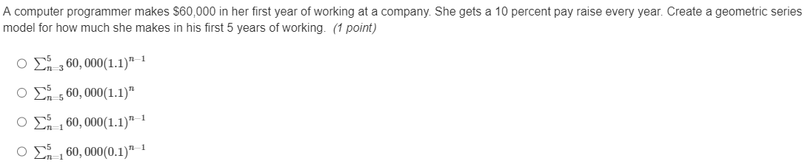 | $$\sum_{n=1}^{5}{{60,000(1.1)}^{n-1}}$$
Q 4 | 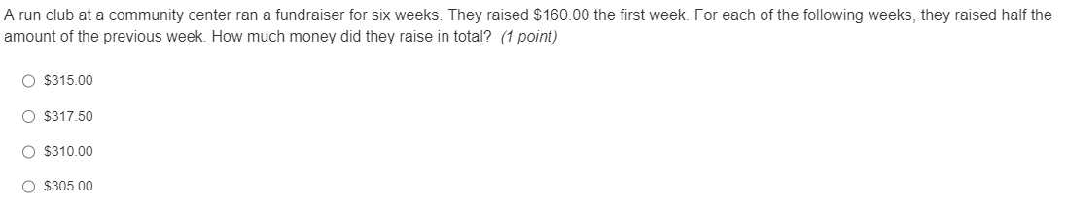 | $315.00
Q 5 | 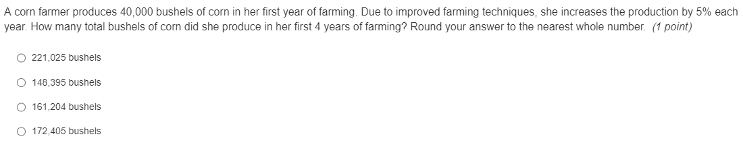 | 172,405 bushels

Lesson 3 – The Sum of a Finite Geometric Series
Key Words:
- sequence – a set of numbers that follow a specific pattern or formula
Objective 1: In this section, you will derive the formula for the sum of a finite geometric series.
Mathematical Practice Standard: Model with mathematics.
Big Ideas:
- When there are more than a few terms within a geometric series, use a formula to find the sum of a finite geometric series.
- The formula to sum a finite geometric series is: $S_{n}=\frac{a-{ar}^{n}}{(1-r)}$
  - Keep in mind, this formula only works when $r≠1.$
Objective 2: In this section, you will calculate the sum of a finite geometric series when given a geometric sequence.
Mathematical Practice Standard: Model with mathematics.
Big Ideas:
- There are 2 variations of problems where you are given a geometric series and asked to find the sum of the first $n$ terms.
  - First variation – you are given a series and must calculate $r$ before substituting values into the formula $S_{n}=\frac{a-{ar}^{n}}{(1-r)}$.
    - Remember $r$ is the common ratio, so use the information from the problem to divide any term in the series by the previous term.
  - Second variation – you must calculate the sum of a finite geometric series when given a geometric sequence. This is when you are given two terms of the series that do not include the first term and in which you must calculate both $r$ and $a$ before using the formula $S_{n}=\frac{a-{ar}^{n}}{(1-r)}$
    - Ex: Find the sum of the six terms of the geometric series in which the third and fourth terms are 500 and 250.
      - $n=6$
      - Calculate $r: \frac{250}{500}=\frac{1}{2}$
      - Use $r$ to work backwards and calculate terms to find the initial term, $a.$
        - You are looking for term 1 and term 2 since the problem listed terms three and 4 are 500 and 250.
        - Find term 2: $500÷\frac{1}{2}=1,000$
        - Find term 1 or $a$: $1,000÷\frac{1}{2}=2,000$
          - $a=2,000$
      - Now use the formula $S_{n}=\frac{a-{ar}^{n}}{(1-r)}$
        - $S_{6}=\frac{2,000-(2,000){(\frac{1}{2})}^{6}}{(1-.5)}$
        - $S_{6}=\frac{2,000-31.25}{.5}$
        - $S_{6}=3,937.5$ The sum of the first six terms of the geometric series is 3,937.5.
Practice Questions and Answers
 | Question | Answer
P 1 | 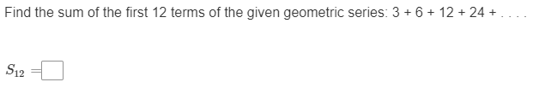 | 12,285
P 2 | 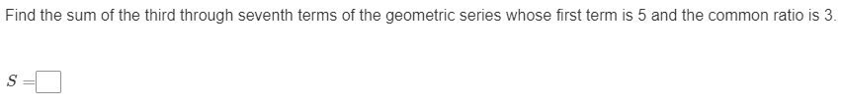 | 5,445
P 3 | 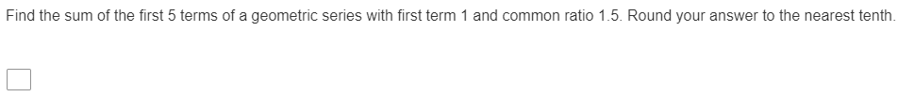 | 13.2
P 4 | 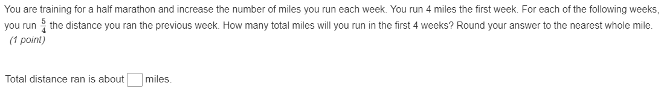 | 23
P 5 | 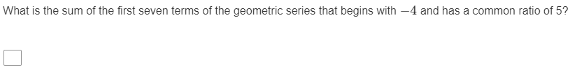 | -78,124

Quick Check Questions and Answers
 | Question | Answer
Q 1 | 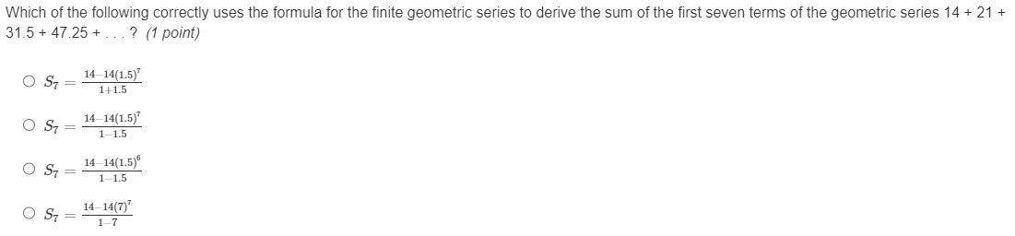 | $$S_{7}=\frac{14-{14(1.5)}^{7}}{(1-1.5)}$$
Q 2 | 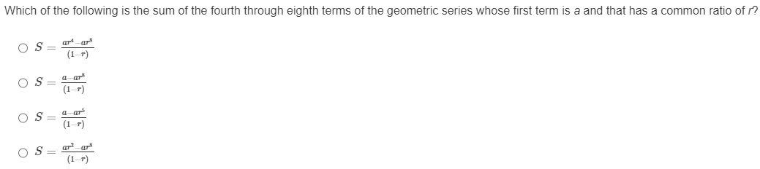 | $$S_{}=\frac{{ar}^{3}-{ar}^{8}}{(1-r)}$$
Q 3 | 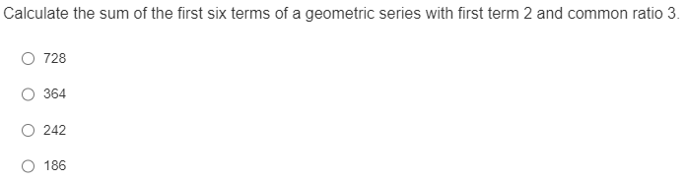 | 728
Q 4 |  | 310
Q 5 | 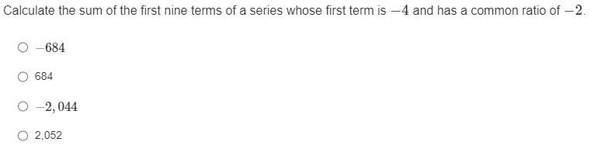 | -684

Lesson 4 – Sigma Notation
Key Words:
- common ratio – the ratio of each term of a geometric progression to its preceding term
- geometric series – a series (such as $1+x+x^{2}+x^{3}+…$) whose terms form a geometric progression

Objective 1: In this section, you will express the formula for the sum of a finite geometric series in sigma notation.
Mathematical Practice Standard: Model with mathematics.
Big Ideas:
- Sometimes you will be given the formula to sum a finite geometric series$,{ S}_{n}=\frac{a-{ar}^{n}}{(1-r)}$ , and will have to write it in sigma notation, $\sum_{n=1}^{n}{{ar}^{n-1}}$.
  - Ex: Write${ S}_{13}=\frac{5-{(5)(2)}^{13}}{(1-2)}$ in sigma notation.
    - Step 1: Identify the variables from the formula:
      - $n=13$
      - $r=2$
      - $a=5$
    - Step 2: plug those variables into the sigma notation
      - $\sum_{n=1}^{13}{{(5)(2)}^{13-1}}$
    - Step 3: simplify where possible
      - $\sum_{n=1}^{13}{{(5)(2)}^{12}}$
- There is another way you might see the formula of the sum of a finite geometric series,
${ S}_{n}=a_{1}\frac{(1-r^{n})}{(1-)}$. In this format, $a$ has been factored in the numerator and brough in front of the fraction. Follow the same steps as above to identify each variable from the given formula and plug them into the sigma notation.
Objective 2: In this section, you will write the series represented by a sum given in sigma notation.
Mathematical Practice Standard: Model with mathematics.
Big Ideas:
- In order to identify the series, you must use the ${ar}^{n-1}$ expression to calculate each term by using values for $n$, from 1 to $n$. This is the same process as manually finding the sum of the first terms from lesson 2.
  - Ex: $\sum_{n=1}^{4}{{(3)(2)}^{n-1}}$
    - $n=4$, so you need to calculate ${(3)(2)}^{n-1}$ substituting in values for $n$, from 1 through 4
$${(3)(2)}^{1-1}+{(3)(2)}^{2-1}+{(3)(2)}^{3-1}+{(3)(2)}^{4-1}$$ | Write out the equation to calculate
$${(3)(2)}^{0}+{(3)(2)}^{1}+{(3)(2)}^{2}+{(3)(2)}^{3}$$ | Simplify
$$(3)(1)+(3)(2)+(3)(4)+(3)(8)$$ | Calculate
$$3+6+12+24$$ | This is the series

Practice Questions and Answers
 | Question | Answer
P 1 | 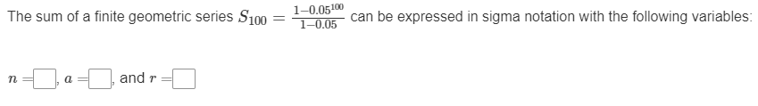 | $$n=100$$  $$a=1$$  $$r=0.05$$
P 2 | 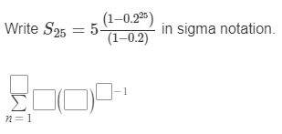 | $$\sum_{n=1}^{25}{{a5(0.2)}^{n-1}}$$
P 3 | 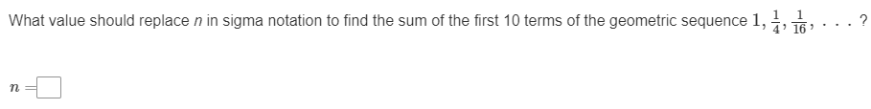 | $$n=10$$
P 4 | 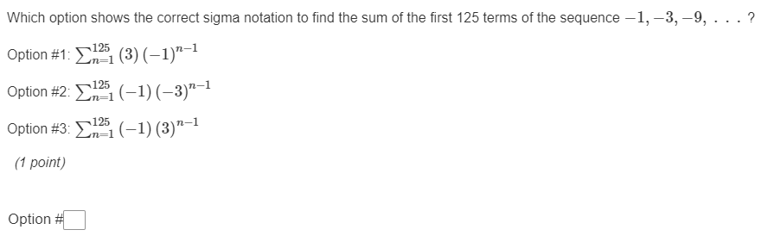 | Option 3
P 5 | 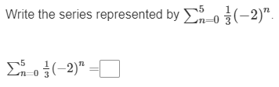 | $$\frac{1}{3}-\frac{2}{3}+\frac{4}{3}-\frac{8}{3}+\frac{16}{3}-\frac{32}{3}$$

Quick Check Questions and Answers
 | Question | Answer
Q 1 | 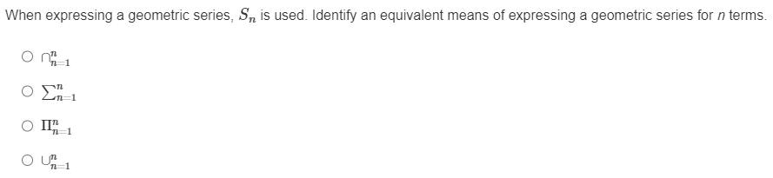 | $$\sum_{n=1}^{n}{}$$
Q 2 | 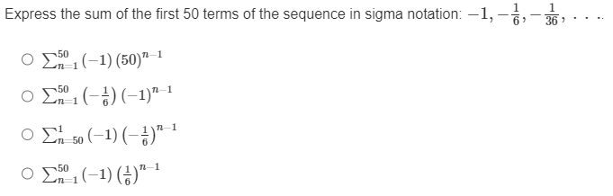 | $$\sum_{n=1}^{50}{{(-1)(\frac{1}{2})}^{n-1}}$$
Q 3 | 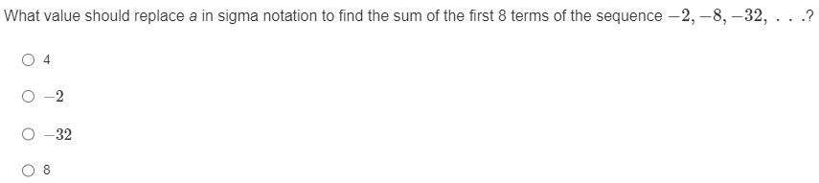 | -2
Q 4 | 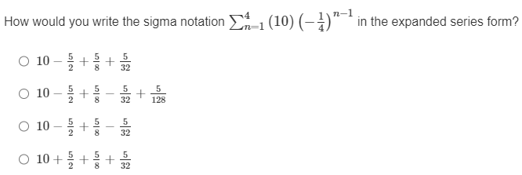 | $$10-\frac{5}{2}+\frac{5}{8}-\frac{5}{32}$$
Q 5 | 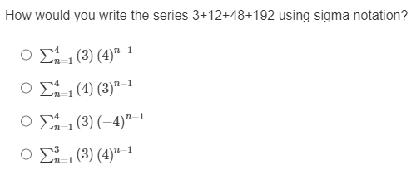 | $$\sum_{n=1}^{4}{{\#3)(4)}^{n-1}}$$

Lesson 5 – Saving Money
Key Words:
- annuity – a sum of money payable yearly or at other regular intervals
- compound – to pay (interest) on both the accrued interest and the principal
- future value of an annuity – the value of an annuity after a certain number of payments
Objective 1: In this section, you will adapt the formula for the sum of a finite geometric series to express the future value of an annuity.
Mathematical Practice Standard: Model with mathematics.
Big Ideas:
- This is the formula for calculating the future value of an annuity $FV=P\frac{{(1+r)}^{n}-1}{r}$
  - $n$ = the number time periods, (or payments)
  - $P$ = the amount of the payment (or investment)
  - $r$ = periodic interest rate (in decimal form)
- The future value of annuity formula can only be used:
  - when the common ratio is constant; in other words, when the Payment and the interest rate are constant and change at the same rate (for example if they are both yearly or monthly.)
Objective 2: In this section, you will calculate the future values of annuities in the context of saving money.
Mathematical Practice Standard: Model with mathematics.
Big Ideas:
- Use the $FV=P\frac{{(1+r)}^{n}-1}{r}$ formula to calculate the future value of an annuity.
- Critical step before using the formula to solve a problem:
  - ensure that the payment and interest rate are at the same frequency. You may have to convert a yearly interest rate or payment amount to monthly or vice versa to get at the same frequency.
  - Ex: You have a savings account with a 7.5 percent annual interest rate and invest $50 a month into the account. How much will the account have in it (assuming no withdrawals) after two years?
    - You know the monthly payment is $50, so $P=50$
    - The annual interest rate is 7.5 percent, so divide that by 12 to get the monthly interest rate.
      - $\frac{7.5\%}{12}=0.625\%$
      - Convert the percent per month to a decimal: $r=\frac{0.625}{100}=0.00625$
    - You know the number of monthly payments is 24 (2 years), so $n=24.$
    - Use the formula to solve the problem
Formula | $$FV=P\frac{{(1+r)}^{n}-1}{r}$$
Enter values and calculate | $$FV=50\frac{{(1+0.00625)}^{24}-1}{0.00625}$$
Answer | $$FV=\$1,290.34$$

Practice Questions and Answers
 | Question | Answer
P 1 | 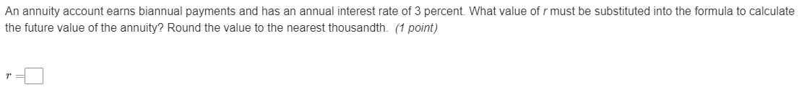 | 0.015
P 2 | 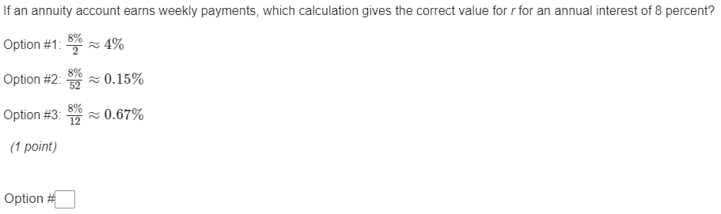 | Option 2
P 3 | 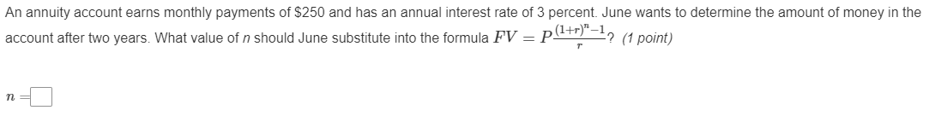 | 24
P 4 | 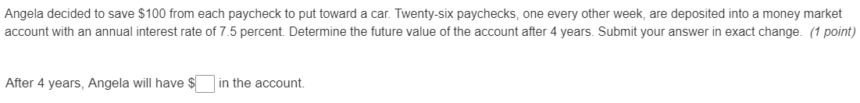 | $12,108.49
P 5 | 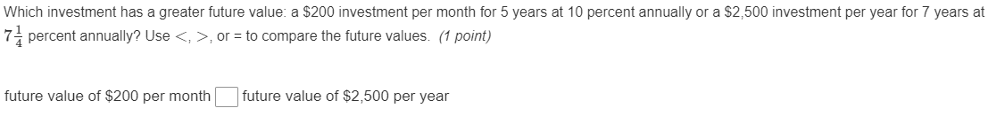 | $$<$$

Quick Check Questions and Answers
 | Question | Answer
Q 1 | 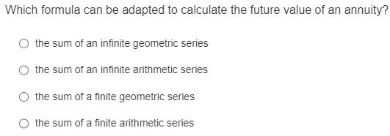 | the sum of a finite geometric series
Q 2 | 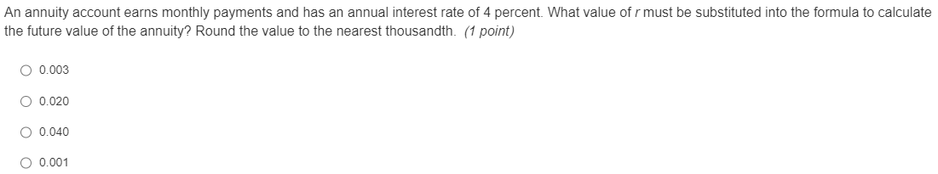 | 0.003
Q 3 | 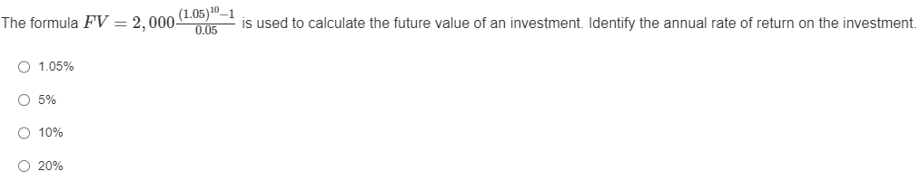 | 5%
Q 4 | 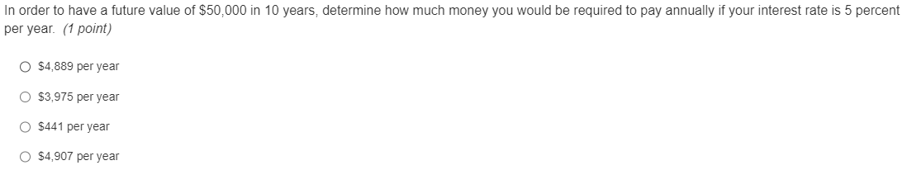 | $3,975 per year
Q 5 | 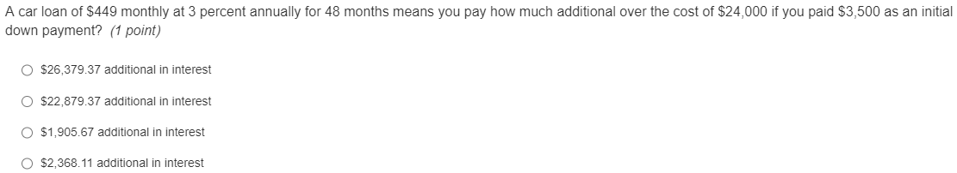 | $2,368.11 additional in interest

Lesson 6 – Spending Money
Key Words:
- annual percentage rate (APR) – a measure of the annual percentage cost of consumer credit (as in installment buying or a charge account) that is required by law to appear on statements of credit accounts and is variously computed but always takes into consideration the amount financed, the amount of the finance charges, and the schedule of repayment
- compounded interest – interest computed on the sum of an original principal and accrued interest
- present value of an annuity – the sum that must be invested now to guarantee a desired value in the future
- principal – an original sum invested or lent

Objective 1: In this section, you will explain how the formula for the future value of an annuity can be adapted for large purchases that require regular payments.
Mathematical Practice Standard: Model with mathematics.
Big Ideas:
- Real life application: Use the future value of annuity formula to compare payment plan options. This will help you determine the true cost of each option and allow you to make an informed decision when choosing.
- You can use the future value of an annuity formula to calculate payments.
  - Ex: You would like to save $1,000 in a year in a savings account with an APR of 2 percent.
  - Identify/calculate the variables:
    - $FV=\$1,000$
    - $r=\frac{2\%}{12}$or 0.001667
    - $n=12$
    - $P$ = unknown
  - Use the future value of an annuity formula to calculate the monthly payment:
Formula | $$FV=P\frac{{(1+r)}^{n}-1}{r}$$
Enter values and calculate | $$1,000=P \frac{{(1+0.001667)}^{12}-1}{0.001667}$$
Simplify and solve for $P$ | $$1000=P ∙12.11067$$
Answer | $$P=\$87.57$$

Objective 2: In this section, you will calculate the payment plan to determine the present value of an annuity.
Mathematical Practice Standard: Model with mathematics.
Big Ideas:
- Use this formula to calculate the present value of an annuity: $PV=P\frac{1-{(1+r)}^{-n}}{r}$
  - In this formula:
    - $PV$ = present value of an annuity
    - $r=$ interest rate per time period
    - $n=$ the number of time periods
    - $P$ = annuity payment
- Real life applications: Use the present value of annuity formula to:
  - calculate monthly payments that include an interest rate
  - calculate monthly payments based on the known amount of money (principal) borrowed
  - find out how much of your payments have been paid toward the principal of a loan.
Practice Questions and Answers
 | Question | Answer
P 1 | 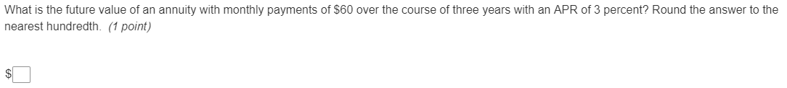 | $2,257.23
P 2 | 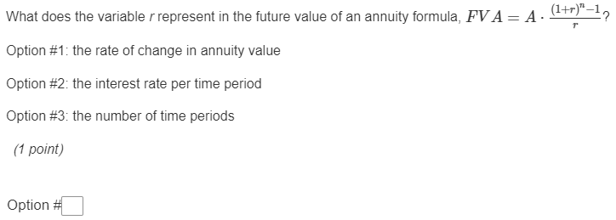 | Option 2
P 3 | 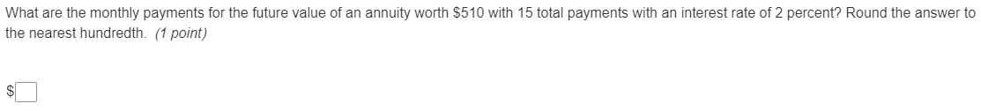 | $33.61
P 4 | 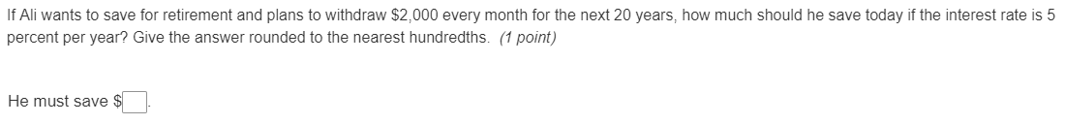 | $303,050.63
P 5 | 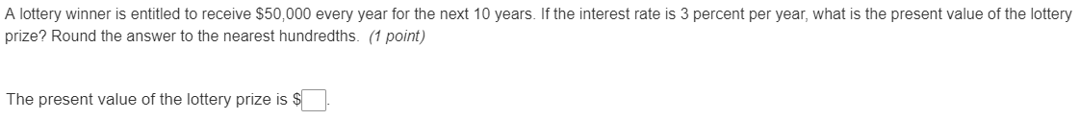 | $426,510.14

Quick Check Questions and Answers
 | Question | Answer
Q 1 | 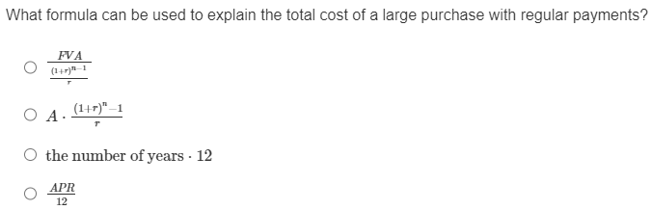 | $$PV=A\frac{1-{(1+r)}^{-n}}{r}$$
Q 2 | 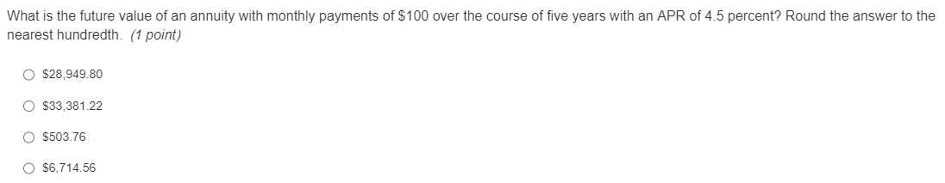 | $6.714.56
Q 3 | 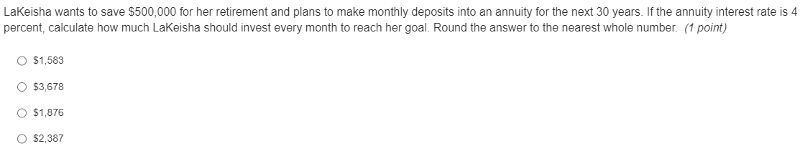 | $2,387
Q 4 | 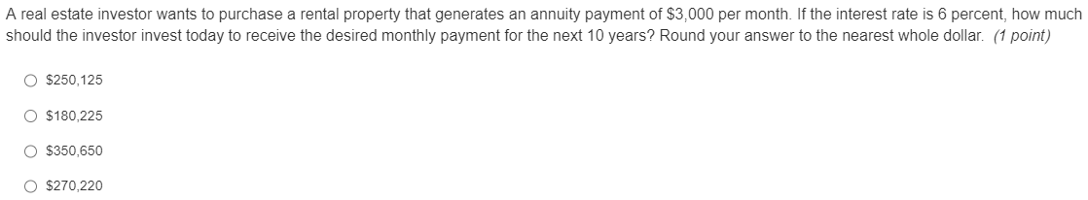 | $270,220
Q 5 | 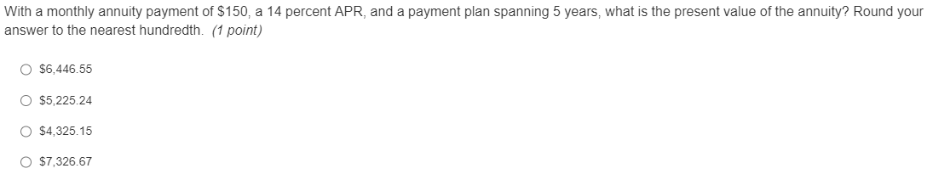 | $6,446.55
Lesson 7 – Finite Geometric Series Apply
Lesson 8 – Finite Geometric Series Review
Lesson 9 – Finite Geometric Series Unit Test

