Algebra 2 B

**Unit 3: Exponential & Logarithmic Functions**

**Unit Summary:** In this unit, you will explore deeper connections between Exponential and Logarithmic functions by graphing them, transforming and interpreting their graphs, and using their graphs to solve exponential and logarithmic equations.

**Lesson 2 – Locating Irrational Numbers**

**Key Words:**

* **interval** – a set of real numbers between two numbers either including or excluding one or both of the numbers
* **irrational number** – a number that can be expressed as an infinite decimal with no set of repeating consecutive digits; it cannot be expressed as the quotient of two integers
* **lower bound** – the smallest value that would round up to an estimated value
* **operation** – any of various mathematical or logical processes (such as addition) of deriving one entity from others according to a rule
* **rational number** – a number that can be expressed as an integer or the quotient of an integer divided by a nonzero integer
* **upper bound** – the largest value that would round down to an estimated value

**Objective 1:** In this section, you will locate irrational numbers on a number line by squeezing them into increasingly smaller intervals.

*Mathematical Practice Standard: Model with mathematics.*

**Big Ideas**:

* It is helpful to know the perfect squares from 1-20 when plotting irrational numbers on a number line – use this reference table:
  + 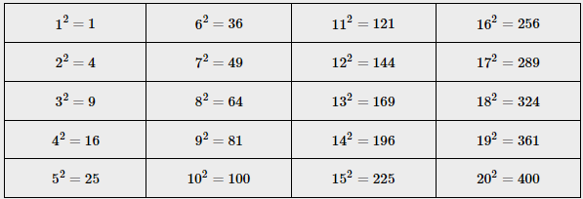
* The square root of any number that is NOT a perfect square is an irrational number.
  + Ex: $\sqrt{2}=an irrational number$; $\sqrt{12}=an irrational number$
* To plot an irrational number on a number line without a calculator, follow these steps:
  + Step 1 – determine the two perfect squares that the irrational number falls between
    - Ex: $\sqrt{2}$ is between $\sqrt{1}$ and $\sqrt{4}$
    - 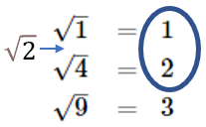
  + Step 2 – determine which of the two perfect squares the irrational number falls closer to
    - Ex: $\sqrt{2}$ is closer to $\sqrt{1}$ than $\sqrt{4}$ because the $\sqrt{2}$ is one number away from $\sqrt{1}$ (2 – 1 = 1) compared to being 2 numbers away from $\sqrt{4}$ (4 – 2 = 2). So we know that $\sqrt{2}$ falls closer to 1 than 2 on a number line.
* To check your work with a calculator, follow these steps:
  + Step 1 – input the square root into the calculator to find the irrational number
    - Ex: $\sqrt{2}$ = 1.44213562…
  + Step 2 – Confirm the irrational number is between the two numbers previously identified on the number line
    - Ex: 1.44213562… is between 1 and 2 (closer to 1)
  + Step 3 – Determine how accurate the estimate needs to be according to the problem being solved
    - Ex: 1.44213562… is between 1.41 and 1.42;
    - with even more accuracy, 1.44213562… is between 1.414 and 1.415

**Objective 2:** In this section, you will perform operations on irrational numbers by making increasingly smaller rational approximations.

*Mathematical Practice Standard: Model with mathematics.*

**Big Ideas:**

* Rational numbers are numbers that can be written as ratio of two integers, or fractions. They can be expressed as a decimal that terminates. For example, $\frac{3}{8}=0.375.$ They can also repeat infinitely in a predictable manner. For example, $\frac{1}{11}=0.09090909…$.
* Irrational numbers cannot be written as a ratio of two integers. They can be expressed as nonterminating decimals that continue to infinitely in no predictable manner. For example, $π=3.14159…$.
* The best method for performing operations on irrational numbers is to perform an approximation.
  + Determine how accurate the approximation needs to be according to the problem being solved.
  + Ex: $π=3.14159…$ is between
    - 3.14 and 3.15 (hundredth place)
    - 3.1415 and 3.1416 (ten-thousandth place)
  + This method of “squeezing” irrational numbers in between two irrational numbers is essential to completing irrational operations.
  + Follow these steps for “squeezing” irrational numbers in between two rational numbers when completing irrational operations:
    - Step 1: determine the two perfect square numbers that the radical falls between.
    - Step 2: determine which of the two numbers the radical in question is closer to.
    - Step 3: place the point on the number line based on steps 1 and 2. This is the estimated value of the radical.
    - Step 4: check your work – use a calculator to determine the exact value of the radical and reflect on your placement on the number line in step 3.

**Practice Questions and Answers**

|  |  |  |
| --- | --- | --- |
|  | Question | Answer |
| P 1 |  | $$12.5<\sqrt{164}<13.0$$ |
| P 2 |  | $$1.5<\sqrt{3}<2$$ |
| P 3 |  | R = 16, S = 16.5 |
| P 4 |  | 0.2873 |
| P 5 |  | 1.73206 |

**Quick Check Questions and Answers**

|  |  |  |
| --- | --- | --- |
|  | Question | Answer |
| Q 1 |  | 7 and 7.5 |
| Q 2 |  | X = 289  y = 324 |
| Q 3 |  | 4.8818 |
| Q 4 |  | 4.8736 |
| Q 5 |  | 1.04140 |

**Lesson 3 – Graphing Logarithmic Functions**

**Key Words:**

* **common logarithmic function** – a logarithmic function whose base is 10
* **domain** – the set of input values for which a function is defined
* **end behavior of a polynomial** – the description of the trend of a polynomial’s graph as the input variable approaches positive infinity to the right and negative infinity to the left
* **natural logarithmic function** – a logarithmic function whose base is $e$
* **range** – the set of all possible output ($y$) values of a function
* **vertical asymptote** – a vertical line that a given curve continually approaches but does not meet
* $x$**-intercept –** the point where the graph crosses the $x$-axis
* $y$**-intercept –** the point where the graph crosses the $y$-axis

**Objective 1:** In this section, you will graph logarithmic functions with different bases.

*Mathematical Practice Standard: Model with mathematics.*

**Big Ideas**:

* Reminder about logarithms:
  + Any logarithmic function can be rewritten as an exponential equation.
  + A logarithm takes the same information that exists in an exponential equation and rearranges it so that the exponent is alone on one side of the equation.
  + A logarithmic function is written in the form $y=\log_{b}{x}$, where $b >0$ and $b≠1.$
  + Ex: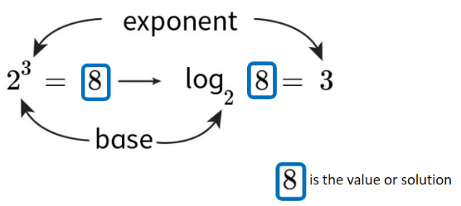
* To graph logarithmic functions, follow these steps:
  + First – rewrite the equation in exponential form
  + Second – create a chart to find the values to graph;
    - since $y$ is the exponent, you can assign values to $y$ and then substitute each value of $y$ into the equation to find the corresponding $x$-value.
  + Third- plot the points and connect them using a smooth curve.
  + Lastly- note the vertical asymptote (a vertical line that a given curve continually approaches but does not meet)

**Objective 2:** In this section, you will identify key features of a logarithmic function.

*Mathematical Practice Standard: Model with mathematics.*

**Big Ideas:**

Use this graph for all examples outlined below:

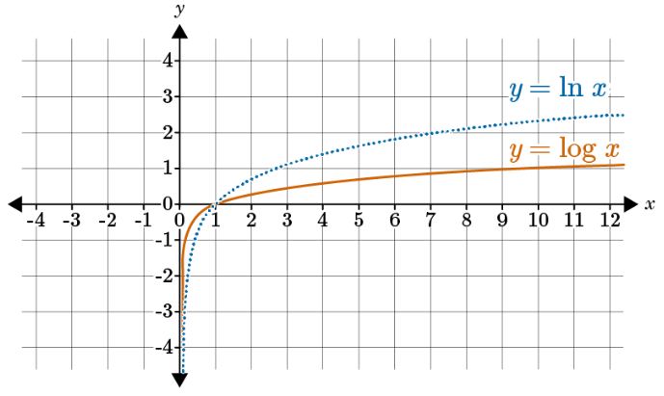

* **domain** – the set of input values for which a function is defined
  + ex: $0<x<∞$
* **end behavior of a polynomial** – the description of the trend of a polynomial’s graph as the input variable approaches positive infinity to the right and negative infinity to the left
  + Ex: As $x→∞, y→∞$
  + Ex: As $x→0^{+}, y→-∞$
    - The notation $x→0^{+}$ describes how the function approaches the line $x=0$ from the right. This is used because the domain of a logarithmic function does not contain negative numbers, so it cannot approach $x=0$ from the left. As $x$ approaches 0 from the right, $y$ approaches negative infinity.
* **range** – the set of all possible output ($y$) values of a function
  + Ex**: $-∞<y<∞$**
* **vertical asymptote** – a vertical line that a given curve continually approaches but does not meet
  + Ex: $x=0$
* $x$**-intercept –** the point where the graph crosses the $x$-axis
  + Ex: (1,0)
* $y$**-intercept –** the point where the graph crosses the $y$-axis
  + If a y-intercept is part of the graph, it is written as a coordinate, example (0,2)

**Objective 3:** In this section, you will compare the key features of logarithmic functions with different bases.

*Mathematical Practice Standard: Model with mathematics.*

**Big Ideas:**

Big ideas from these pages of the lesson were noted in objective 2 Big Ideas above.

**Practice Questions and Answers**

|  |  |  |
| --- | --- | --- |
|  | Question | Answer |
| P 1 |  | 10 |
| P 2 |  | X=8 |
| P 3 |  | 0 |
| P 4 |  | 3 |
| P 5 |  | 9 |

**Quick Check Questions and Answers**

|  |  |  |
| --- | --- | --- |
|  | Question | Answer |
| Q 1 |  | $$\log_{0.5}{x}$$ |
| Q 2 |  | X=0 |
| Q 3 |  | $$b=\frac{1}{4}$$ |
| Q 4 |  | As $x→0^{+}, y→-∞,$ and as $x→∞$, $y→∞$ |
| Q 5 |  | Functions $f(x)$ and $g(x)$ will have similar shapes but will increase at different rates. |

**Lesson 4 – Corresponding Exponential & Logarithmic Functions**

**Key Words:**

* **exponential function –** an equation in the form $f\left(x\right)=a∙b^{x}$ in which the independent variable appears in the exponent
* **logarithmic function** – a function that is the inverse of an exponential function so that the independent variable appears in a logarithm

**Objective 1:** In this section, you will compare the key features of an exponential function to that of its corresponding logarithmic function.

*Mathematical Practice Standard: Make sense of problems and persevere in solving them.*

**Big Ideas**:

* Remember – exponential functions and logarithmic functions are related; It is helpful to rewrite logarithmic functions as exponential functions in order to graph and solve them.
* The following is true for an exponential function and it’s corresponding logarithmic function (regardless of the base):
  + The key features will be reversed.
    - The domain of the exponential function will be the range of the corresponding logarithmic function.
    - The range of the exponential function will be the domain of the corresponding logarithmic function.
    - The $y$-intercept of the exponential function will be the $x$-intercept of the corresponding logarithmic function.
    - An exponential function’s horizontal asymptote will be the corresponding logarithmic function’s vertical asymptote.

**Objective 2:** In this section, you will describe the geometric relationship between the graph of an exponential function and its corresponding logarithmic function.

*Mathematical Practice Standard: Reason abstractly and quantitatively.*

**Big Ideas:**

* The graph of any exponential function and its corresponding logarithmic function will be reflections of one another across the line $y=x.$
  + This means that the $x$ and $y$ coordinates are reversed.

**Practice Questions and Answers**

|  |  |  |
| --- | --- | --- |
|  | Question | Answer |
| P 1 |  | 7 |
| P 2 |  | 16 |
| P 3 |  | 5 |
| P 4 |  | 4.011 |
| P 5 |  | 1.5563 |

**Quick Check Questions and Answers**

|  |  |  |
| --- | --- | --- |
|  | Question | Answer |
| Q 1 |  | The first step is to rewrite the expression using addition, such that $\log\left({10}^{7}∙5\right)=\log{{10}^{7}+\log{5.}}$ |
| Q 2 |  | 7 |
| Q 3 |  | 2.565 |
| Q 4 |  | 4.007 |
| Q 5 |  | $$\log{3+\log{8}}$$ |

**Lesson 5 – Inverse Relationships**

**Key Words:**

* **composition of functions** – the placement of a function in another to evaluate the result
* **horizontal line test** – a test used to determine if a function is one-to-one; if a function would intersect a horizontal line only once, then the function is one-to-one
* **inverse function** – a function that is derived from a given function by interchanging the two variables
* **one-to-one function** – a function in which each value in the range is paired with only one value in the domain

**Objective 1:** In this section, you will explore inverse functions graphically and numerically.

Mathematical Practice Standard: Use appropriate tools strategically.

**Big Ideas**:

* Two functions are inverses if their compositions both simplify to the original domain value $x.$
  + Ex: $f\left(g\left(x\right)\right)=F\left(\frac{x+3}{2}\right)=2 \left(\frac{x+3}{2}\right)-3=x+3-3=x$ $g\left(f\left(x\right)\right)=g\left(2x-3\right)= \frac{2x-3+3}{2}=\frac{2x}{2}=x$
    - Simplifying both shows that no matter what the value of the domain input, $x$, the composition of functions will result in the output of the same input value, $x.$
    - Because both compositions give the value of $x$, the original domain value, then $g$ is the inverse of $f$. You can write $f^{-1}\left(x\right)= \frac{x+3}{2}$. Use this definition to test two functions to determine whether or not they are inverses.
* Not every function has an inverse.
  + In order for a fucntion to have an inverse, it must be a one-to-one function. A one-to-one function is a function in which each value in the range is paired with only one value in the domain.
* Reflection on a graph is another way that you can determine whether two functions are inverses. If two functions are inverses, then their graphs will be a reflection across the line $y=x.$
  + if you fold a graph along the dashed line $y=x$, the two functions would match up.

**Objective 2:** In this section, you will find the formula for an inverse function algebraically.

*Mathematical Practice Standard: Make sense of problems and persevere in solving them.*

**Big Ideas:**

* How to determine if a function is one-to-one:
  + Graph the function and do a horizontal line test.
  + The horizontal line test involves passing a horizontal line across a function and examining any points of intersection. If a horizontal line creates only one point of intersection along the entire graph, then the function is one-to-one. If a horizontal line creates more than one point of intersection along the graph, then the function is NOT one-to-one.
  + Follow these steps to algebraically determine the inverse of a function:
  + Algebraically: follow these steps
    - * Step 1 – Verify that the function is one-to-one.
      * Step 2 – Substitute $y$ for the function name.
      * Step 3 – Switch all $x$ and $y$-values.
      * Step 4 – Solve the equation for $y.$
      * Step 5 – Replace $y$ with $f^{-1}\left(x\right)$ or the appropriate function name.
    - Ex: $f\left(x\right)=5x-2$

|  |  |
| --- | --- |
| $$f\left(x\right)=5x-2$$ | Original function |
| $$y=5x-2$$ | Substitute $y$ for $f(x)$ |
| $$x=5y-2$$ | Replace all $x$-values with $y$, and all $y$-values with $x$ |
| $$x+2=5y$$ | Start solving for $y$ by adding 2 to both sides |
| $$\frac{(X+2)}{5}=y$$ | Divide both sides by 5 |
| $$f^{-1}\left(x\right)=\frac{(x+2)}{5}$$ | Replace $y$ with |

* + - * The inverse function of $f\left(x\right)=5x-2$ is $f^{-1}\left(x\right)=\frac{(x+2)}{5}$.

**Objective 3:** In this section, you will establish that the functions $f\left(x\right)=\log_{b}{x}$ and $g\left(x\right)=b^{x}$ are inverses of each other

*Mathematical Practice Standard: Look for and make use of structure.*

**Big Ideas:**

* Exponential equations and their corresponding logarithmic equations are inverses.
  + Graphical Ex: $f\left(x\right)=2^{x}$ and $g\left(x\right)=\log_{2}{x}$
    - The $x$ and $y$ coordinates are reversed.
      * 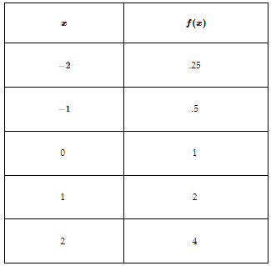 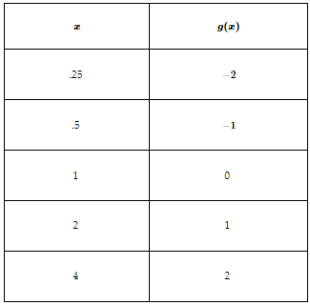
    - The graph of any exponential function and its corresponding logarithmic function will be reflections of one another across the line $y=x.$
      * 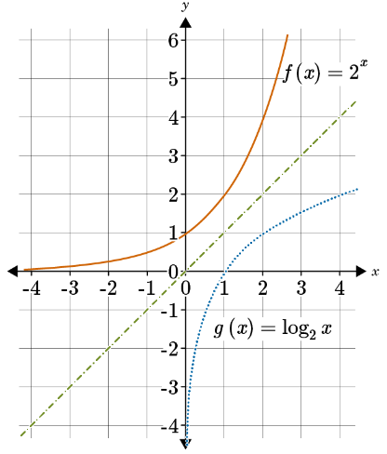
  + Algebraic Ex:

|  |  |
| --- | --- |
| $$f\left(x\right)=2^{x}$$ | Original function |
| $$y=2^{x}$$ | Substitute $y$ for $f(x)$ |
| $$y=2^{x}$$ | Replace all $x$-values with $y$, and all $y$-values with $x$ |
| $$y=\log_{2}{x}$$ | Rewrite the exponential equation into a logarithmic equation |
| $$f^{-1}\left(x\right)=\log_{2}{x}$$ | Replace $y$ with $f^{-1}(x)$ (the name of the inverse) |

* + - The inverse of $f(x)$, written as $f^{-1}(x)$ is the same as $g\left(x\right).$
      * $f\left(x\right)=2^{x}$ and $g\left(x\right)=\log_{2}{x}$

**Practice Questions and Answers**

|  |  |  |
| --- | --- | --- |
|  | Question | Answer |
| P 1 |  | 1 |
| P 2 |  | 3 |
| P 3 |  | $$\frac{9}{5}$$ |
| P 4 |  | $$\frac{2}{3}$$ |
| P 5 |  | -5 |

**Quick Check Questions and Answers**

|  |  |  |
| --- | --- | --- |
|  | Question | Answer |
| Q 1 |  | $$4\log{2}$$ |
| Q 2 |  | 0.778 |
| Q 3 |  | 2.094 |
| Q 4 |  | $$\frac{4}{5}\log{10}$$ |
| Q 5 |  | 4 |

**Lesson 6 – General Form of an Exponential Function**

**Key Words:**

* **horizontal asymptote** – a horizontal line that a given curve continually approaches but does not meet
* **non-rigid transformation** – a transformation that changes the original shape of the function
* **parent function** – the simplest function in a family of functions
* **rigid transformation** – a transformation that preserves the original shape of the function
* **transformation** – a change in a parent function through addition, subtraction, or multiplication of constants
* **Negative Exponent Rule** – a rule stating that a base written with a negative exponent can be rewritten with a positive exponent by taking the inverse: $b^{-m}=\frac{1}{b^{m}},\frac{1}{b^{-m}}=b^{m}$
* **Power Rule of Exponents** – a rule stating that when raising a base with an exponent to a power, multiply the power by the exponent: ${\left(b^{m}\right)}^{n}=b^{m-n}$
* **Product Rule of Exponents** – a rule stating that when multiplying same bases, add the exponents: $b^{m}∙b^{n}=b^{m+n}$
* **Quotient Rule of Exponents** – a rule stating that when dividing same bases, subtract the exponents: $\frac{b^{m}}{b^{n}}=b^{m-n}$

**Objective 1:** In this section, you will identify the transformations in the functions of the form $f\left(x\right)={ab}^{z-h}+k.$

*Mathematical Practice Standard: Make sense of problems and persevere in solving them.*

**Big Ideas**:

* Here is a summary table of transformations:

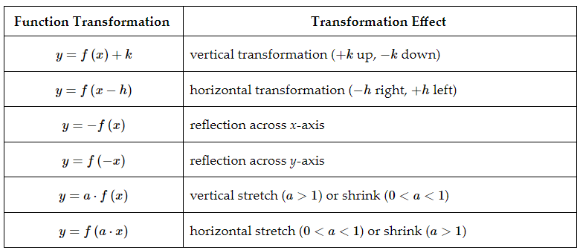

* Rigid transformations are transformations that do not change the shape of the parent function, but do shift (vertically or horizontally) or reflect ( $x$ or $y$ axis) the function.
* Non-rigid transformation is one that changes the shape of the parent function by stretching or shrinking the function, which would result in changing the shape of the parent function.
* Multiple transformations of a function can occur. Be sure to examine each part of the function to identify if multiple transformations are present.

**Objective 2:** In this section, you will use transformations to graph exponential functions of the form $f\left(x\right)={a(b)}^{z-h}+k.$

*Mathematical Practice Standard: Model with mathematics.*

**Big Ideas:**

* Use the transformation summary table in the previous objective notes to identify rigid transformations of graphed exponential functions from the parent function $f\left(x\right)=3^{x}$:

|  |  |  |
| --- | --- | --- |
|  | Transformation | Example on graph |
| $$a\left(x\right)=3^{(x+4)}$$ | horizontal transformation - left 4 | Orange solid line |
| Horizontal asymptote remains $y=0$ | Orange dotted line $∙-∙-∙-∙-∙-∙-$ |
| $$b\left(x\right)=3^{x}+2$$ | Vertical transformation – up 2 | Blue dotted line $∙∙∙∙∙∙∙∙∙∙∙∙∙∙∙∙∙∙∙∙∙∙∙∙∙∙∙∙∙∙∙∙∙∙$ |
| Horizontal asymptote shifts up 2 to be $y=2$ | Black dotted line ---------------------------- |
| $$c\left(x\right)=3^{x-5}-4$$ | Vertical transformation – down 4 | Green dotted line $∙-∙-∙-∙-∙-∙-$ |
| $$c\left(x\right)=3^{x-5}-4$$ | Horizontal transformation – right 5 |
| Horizontal asymptote shifts down by 4 to be $y=-4$ | blue dotted line $∙-∙-∙-∙-∙-∙-$ |

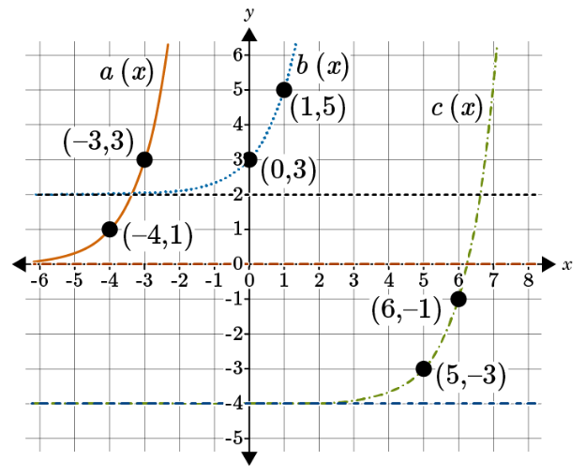

* Use the transformation summary table in the previous objective notes to identify non-rigid transformations of graphed exponential functions from the parent function $f\left(x\right)=2^{x}$:

|  |  |  |
| --- | --- | --- |
|  | Transformation | Example on graph |
| $$a\left(x\right)=-2^{x}$$ | Reflection across $x$-axis | Orange solid line |
| Horizontal asymptote remains $y=0$ | Not specifically identified beyond the $x$-axis line |
| $$b\left(x\right)=3({2)}^{x}$$ | Vertical stretch of 3 | Blue dotted line $∙∙∙∙∙∙∙∙∙∙∙∙∙∙∙∙∙∙∙∙∙∙∙∙∙∙∙∙∙∙∙∙∙∙$ |
| Horizontal asymptote remains $y=0$ | Not specifically identified beyond the $x$-axis line |

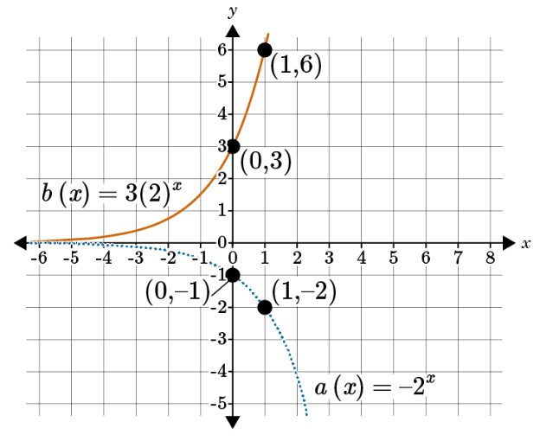

**Objective 3:** In this section, you will use the properties of exponents to rewrite functions of the form $f\left(x\right)={a(b)}^{z-h}+k$ that can be graphed using transformations.

*Mathematical Practice Standard: Make sense of problems and persevere in solving them.*

**Big Ideas:**

* Use these properties of exponents that you’ve previously learned to simplify exponential functions to identify transformations in order to graph the functions:
  + 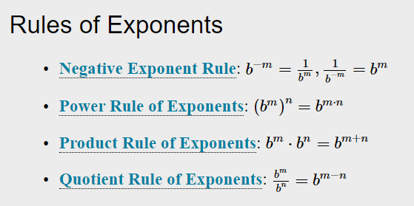
* Once you simplify the exponential function, identify the transformations and use the transformation summary table to graph the function.

**Practice Questions and Answers**

|  |  |  |
| --- | --- | --- |
|  | Question | Answer |
| P 1 |  | $$-4 log{3}$$ |
| P 2 |  | 2 |
| P 3 |  | 1 |
| P 4 |  | 3 |
| P 5 |  | 2 |

**Quick Check Questions and Answers**

|  |  |  |
| --- | --- | --- |
|  | Question | Answer |
| Q 1 |  | $$-2\log{10}$$ |
| Q 2 |  | $$\log_{11}{14-\log_{11}{t}}$$ |
| Q 3 |  | $$3\log{r}-2\log{n}$$ |
| Q 4 |  | $$ln({\frac{11}{p^{3}}})$$ |
| Q 5 |  | $$2\log{x-\log{5-\log{y}}}$$ |

**Lesson 7 – General Form of a Logarithmic Function**

**Key Words:**

* **composite transformation** – two or more transformations performed on the same figure
* **horizontal–shrink** a transformation that causes the graph of a function to shrink toward the y–axis when all the x- coordinates are multiplied by a factor $a$, where $a>1.$
* **horizontal–stretch** a transformation that causes the graph of a function to stretch away from the -axis when all the x- coordinates are multiplied by a factor $a$, where $0>a>1.$
* **natural logarithm** – a logarithm whose base is $e$, or approximately 2.71828 . . .
* **parent function** –the simplest function in a family of functions
* **transformation** – a change in the size, shape, position or orientation of a graph
* **vertical shrink** a transformation that causes the graph of a function to shrink toward the $x$-axis when all the y-coordinates are multiplied by a factor $a$, where $0>a>1.$
* **vertical stretch** a transformation that causes the graph of a function to stretch away from the $x$-axis when all the y- coordinates are multiplied by a factor $a$, where $a>1.$

**Objective 1:** In this section, you will identify transformations of logarithmic functions in the form $f\left(x\right)=a\log_{b}\left(x-h\right)+k.$

*Mathematical Practice Standard: Make sense of problems and persevere in solving them.*

**Big Ideas**:

* Remember: A logarithmic function is the inverse of an exponential function, which means the graph of a logarithmic function is a flipped version of an exponential function along the line $y=x$.
* The graph for a parent function of a logarithmic function contains a curved line that opens downward and to the right of the graph. It also contains an asymptote at the line $x=0$. The graph of a parent logarithmic function will not cross the line at $x=0$.
* These rules can be used to create and describe transformations on logarithmic functions:
  + 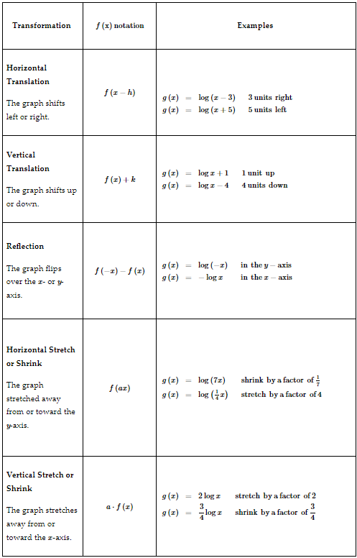
  + Ex: a logarithmic parent function has a vertical shift of 3 units
 $f\left(x\right)=\log{x}$

   - The transformed function is $g\left(x\right)=\log{x+3}$
* Use the transformation rules to identify parent functions from a transformed logarithmic function.
  + Ex: $g\left(x\right)=\log{x+4}$
    - The + 4 in the transformed logarithmic function indicates a vertical shift of 4 units.
    - The parent function is $f\left(x\right)=\log{x}$
* Logarithmic functions can have multiple transformations. These are called composite transformations. Use the chart of rules to identify each transformation.
* These transformation rules are the same for linear, quadratic, exponential and logarithmic functions.

**Objective 2:** In this section, you will use transformations to graph functions of the form $f\left(x\right)=a\log_{b}\left(x-h\right)+k.$

*Mathematical Practice Standard: Model with mathematics.*

**Big Ideas:**

* Follow these steps for graphing parent functions and transformations with this example $f\left(x\right)=\log_{2}{x}$:
  + Step 1: Create a table of values from the function in order to determine points to plot for the parent function.
    - Rewrite the logarithmic function into an exponential function to be able to solve without a calculator: $2^{y}=x$
    - Create the table by plugging in values of $y$ into the exponential function $2^{y}=x:$
      * 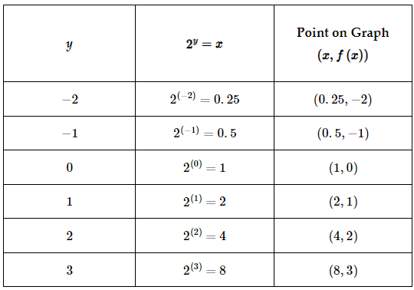
        + Note that for each coordinate form the final column of this table is flipped so that the x-value is listed first, as coordinate points are always written in the form $\left(x,y\right).$
  + Step 2: Plot the coordinate points on a graph:
    - * 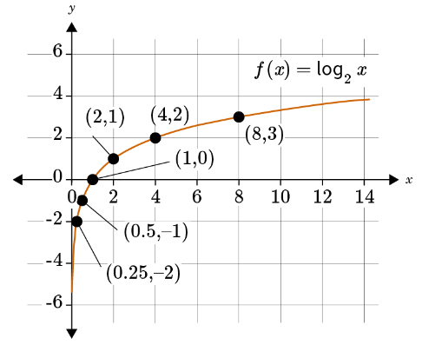
  + Step 3: Create a table of values for a transformation of the parent function. Let’s apply this transformation to the parent function: $g\left(x\right)=\log{(x+3)}$
    - The $x$ in the parent function is preplaced with $x+3.$ Applying this transformation to the parent function yields the following equation: $g\left(x\right)=f\left(x+3\right)=\log_{2}{(x+3})$
    - Rewrite the logarithmic function into an exponential function to be able to solve without a calculator: $2^{y}=x+3$
      * Isolate $x$ or $y$ to effectively chart values to plot on the graph:
 $2^{y}=x+3$

 $-3$ $-3$

 $2^{y}-3=x$

- Create the able with the exponential function $2^{y}-3=x:$
      * 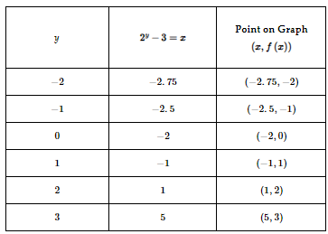
  + Step 4: Plot the points of the transformation on the same graph with the parent function:
    - 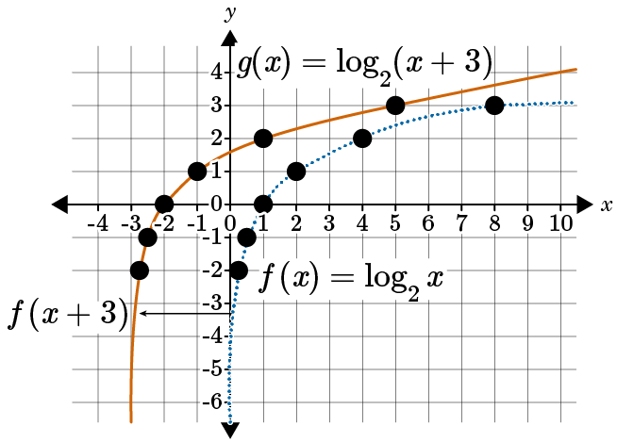
* Sometimes you will be provided a graph and need to determine the parent function and transformation. Use the rules of transformations chart to analyze the graph and determine the function and transformation rule.

**Objective 3:**

*Mathematical Practice Standard:*

**Big Ideas:**

* You can graph logarithmic functions if a vertical stretch or shrink $(a)$, a horizontal shift $(h)$, and a vertical shift $\left(k\right)$ are known.
  + $f\left(x\right)=a\log_{b}\left(x-h\right)+k$ represents a transformation of the parent function $f\left(x\right)=\log_{b}{x}$.
* Logarithmic functions must be in their simplest form in order to graph them accurately. Use properties of logarithms to simplify logarithmic functions so they can be graphed using transformations.
* Properties of Logarithms:

|  |  |
| --- | --- |
| Product Property of Logarithms | $$\log_{b}\left(m∙n\right)=\log_{b}{m+\log_{b}{n}}$$ |
| Quotient Property of Logarithms | $$\log_{b}({\frac{m}{n}})=\log_{b}{m-\log_{b}{n}}$$ |
| Power Property of Logarithms | $$\log_{b}{m^{n}}=n\log_{b}{m}$$ $(b,m,$ and $n$ are positive real numbers, and |

* + Use the properties of logarithms above to simplify logarithmic functions like $f\left(x\right)=\log_{2}({{4x}^{2}})$ or $h\left(x\right)=\log_{3}{(9x-27)}$.

**Practice Questions and Answers**

|  |  |  |
| --- | --- | --- |
|  | Question | Answer |
| P 1 |  | 2 |
| P 2 |  | 3 |
| P 3 |  | A=8, B=0 |
| P 4 |  | 2 |
| P 5 |  | $$f\left(x\right)=\log\left(x-10\right)-2$$ |

**Quick Check Questions and Answers**

|  |  |  |
| --- | --- | --- |
|  | Question | Answer |
| Q 1 |  | Horizontal shift left 7 units |
| Q 2 |  | $$g\left(x\right)=-8\log_{7}\left(x+5\right)-9$$ |
| Q 3 |  | Rewrite the logarithm in exponential form and plug in the $y$-values. |
| Q 4 |  | $$f\left(x\right)=3\log_{2}{x+4}$$ |
| Q 5 |  | 4 units down |

**Lesson 8 – Solving Exponential Equations**

**Key Words:**

* **exponential decay model** – a model whose growth rate decreases over time, following an exponential function
* **exponential equation** – an equation with exponents where the exponent is or contains a variable
* **exponential function** – an equation of the form $f\left(x\right)=a∙b^{x}$ in which the independent variable appears in the exponent
* **exponential growth model** – a model whose growth rate increases over time, following an exponential function

**Objective 1:** In this section, you will solve exponential equations using the properties of logarithms and the inverse relationship between exponential and logarithmic functions.

*Mathematical Practice Standard: Make sense of problems and persevere in solving them.*

**Big Ideas**:

* Use the inverse relationship between logarithmic functions and exponential functions to solve equations.
  + Remember to start by isolating exponential.
  + Ex:

|  |  |
| --- | --- |
| $$7({10)}^{4t}+3=18$$ | Original equation to solve |
| $-3$ $-3$ | Subtract 3 from both sides |
| $$7({10)}^{4t}=15$$ |  |
| $$({10)}^{4t}=\frac{15}{7}$$ | Divide by 7 to isolate the exponential |
| $$d=\frac{15}{7}$$ $$b=10$$ $$ct=4t$$ | Remove the variable from the exponent by using the relationship: $$d=b^{ct} is equivalent to ct\log_{b}{d}$$ First, identify *d*, *b*, and *ct*. |
| $$4t=\log\left(\frac{15}{7}\right)$$ | Remove the variable from the exponent by using the relationship: $$d=b^{ct} is equivalent to ct\log_{b}{d}$$ Transform from an exponential function to a logarithmic function. |
| $$t=\frac{\log\left(\frac{15}{7}\right)}{4}$$ | Divide both sides by 4. |
| $$t=0.083$$ | Use a calculator to get an approximate solution. [Unit 3 Lesson 8 Example - GeoGebra](https://www.geogebra.org/calculator/x265mgbr) |

**Objective 2:** In this section, you will solve exponential equations by locating the point of intersection on a graph of two exponential functions or an exponential and a linear function.

*Mathematical Practice Standard: Make sense of problems and persevere in solving them.*

**Big Ideas:**

* Remember: Previously you found solutions to linear equations and other types of equations by graphing the two equations and locating the point of intersection. A solution for an equation is the point on the graph that the two equations have in common, or in other words, the solution is where the two equations meet.
  + This method can also be applied to exponential functions.
* Exponential equations can be broken into two equations that can be graphed. From this graph you can attempt to find a solution (where the graphs intersect.)
  + Ex: 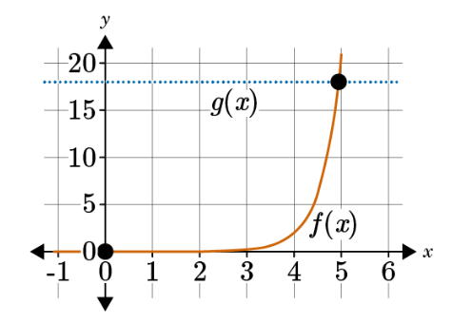
    - The estimate of $x$-value is about 4.9 and the $y$-value is 18 because the function is linear, $g\left(x\right)=18.$
* Verify the solution by algebraically solving the equation.

**Practice Questions and Answers**

|  |  |  |
| --- | --- | --- |
|  | Question | Answer |
| P 1 |  | 2 |
| P 2 |  | 1 |
| P 3 |  | 3 |
| P 4 |  | 1.2 |
| P 5 |  | 42.1 |

**Quick Check Questions and Answers**

|  |  |  |
| --- | --- | --- |
|  | Question | Answer |
| Q 1 |  | 2 |
| Q 2 |  | $$y=20({0.98)}^{10}$$ |
| Q 3 |  | $$y=1,000({1.03)}^{5}$$ |
| Q 4 |  | $$x≈-1.8$$ |
| Q 5 |  | $$x≈1.5$$ |

**Lesson 9 – Exponential & Logarithmic Functions Apply**

Sample work drop box available if teacher would like to collect student work; no Practice or Quick Check

**Lesson 10 – Exponential & Logarithmic Functions Review**

**Lesson 11 – Exponential & Logarithmic Functions Unit Test**